Watch the trailer - https://www.youtube.com/watch?v=ONTglfjX-SA

Peter Bradshaw
Friday 22 April 2011 07.00 AEST
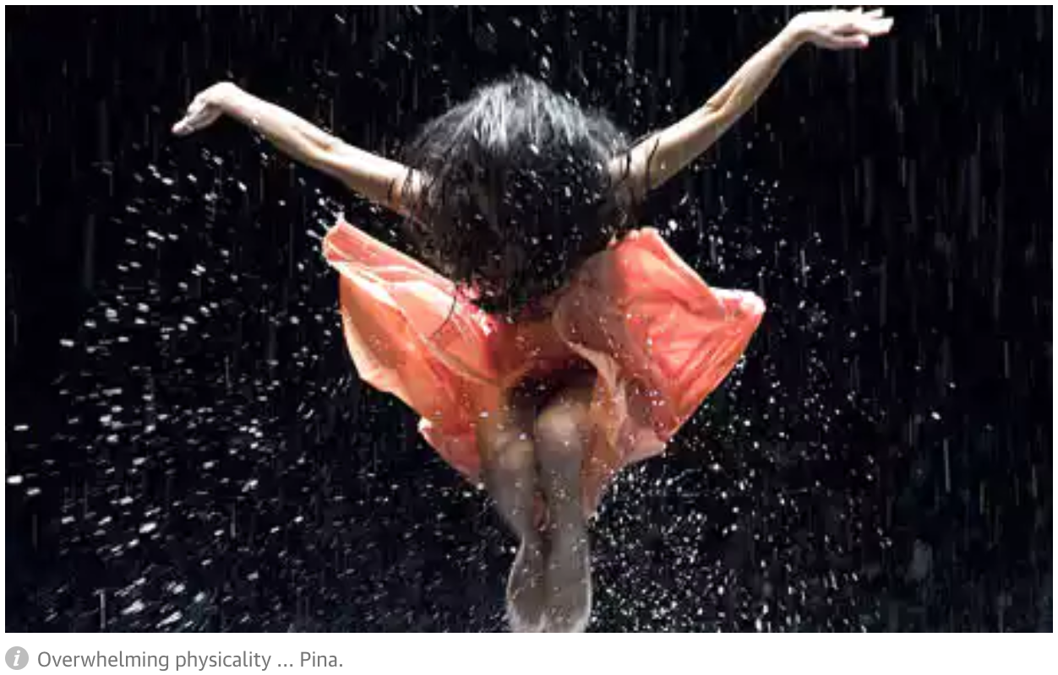

Wim Wenders's deeply intelligent 3D tribute to the work of the modern dance choreographer Pina Bausch was conceived as a collaboration with her. Bausch died during the production in 2009, and the resulting film achieves a poignant, elegaic quality, shot through with an overwhelming sense of loss, both on the part of Bausch's dancers, whose thoughtful interviews and dance sequences form the film's backbone, and the director himself. Bausch was a reticent figure, wary of personalities and insistent on letting her work speak for her. She would undoubtedly have been a distant figure in this film had she lived, but now her absence has a sombre, almost tragic quality. The dancers seem like grownup children who have lost a parent, or even apostles of a spiritual movement whose leader has met some kind of sacrificial destiny.

My colleague Judith Mackrell has already offered her expert verdict on the effect of 3D in filming dance. To her judgment, I can only add that for me, the shapes and forms of the dancers have an overwhelming physicality. The choreography has the air of a mysterious rite, released from the traditional arena of the theatre into the streets, though it is fundamentally filmed head-on, as if through a proscenium arch. (The director has said his inspiration for the film was the U2 3D concert movie.)

If its meaning can be summed up – though it is arguably the point of an abstract artform that it can't be summed up – it is probably in the words of a dancer who asks, "What are we yearning for? Where does all this yearning come from?" We spend our lives yearning, and then, in the shadow of mortality, our yearning is redirected backwards, a yearning to understand our past lives, our youth, and again forwards – a yearning to understand the point of our death. Wenders's movie uncovers the crucial state of yearning in Bausch's work.

Bausch was famously the director of the Wuppertal Tanztheater, where she created pieces such as her Cafe Müller in 1978; this is a very European film, and the artistic practice described in it seems very German in its high seriousness and high-mindedness. Could Bausch have flourished in the same way in Britain, with its broadloid Boulevardpresse and its irony'n'celebs media culture? Perhaps not. But then again, she is perhaps not an obvious fit with Wenders, with his fascination with Americana and pop music. Nonetheless, he has created a tremendous film that sets out to make the new 3D technology an integral part of what is being created – a film with clarity and passion.
https://www.theguardian.com/film/2011/apr/21/pina-review

3-D Tribute to Artistic Impulse
PINA Directed by Wim Wenders Documentary
PG
1h 43m
A. O. SCOTTDEC. 22, 2011

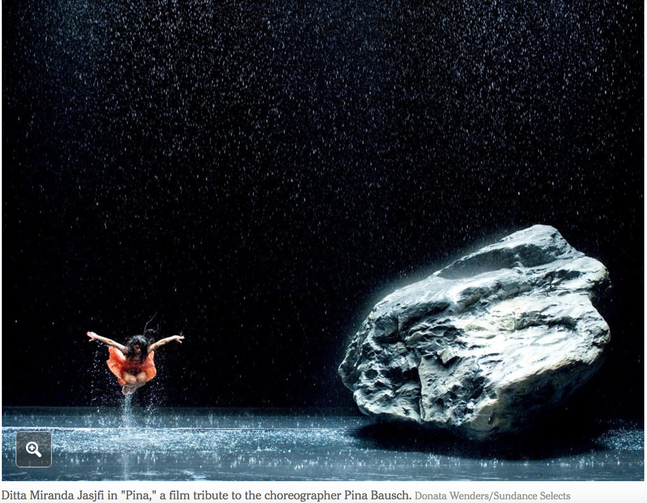

One of the interesting and unexpected film stories of 2011 is about 3-D, which simultaneously lost commercial potency and gained artistic credibility. Those who dismiss the format as the industrial gimmick (and excuse for price gouging) that it frequently is may need to reconsider now that a handful of certified auteurs have given it a try. Steven Spielberg and Martin Scorsese, grand old men of baby-boomer Hollywood, have made 3-D children’s tales (“The Adventures of Tintin” and “Hugo”), which is certainly noteworthy. More remarkable, perhaps even astonishing, is that Werner Herzog and Wim Wenders, stalwarts and survivors of the iconoclastic New German Cinema of the 1970s, have used 3-D in new documentaries.
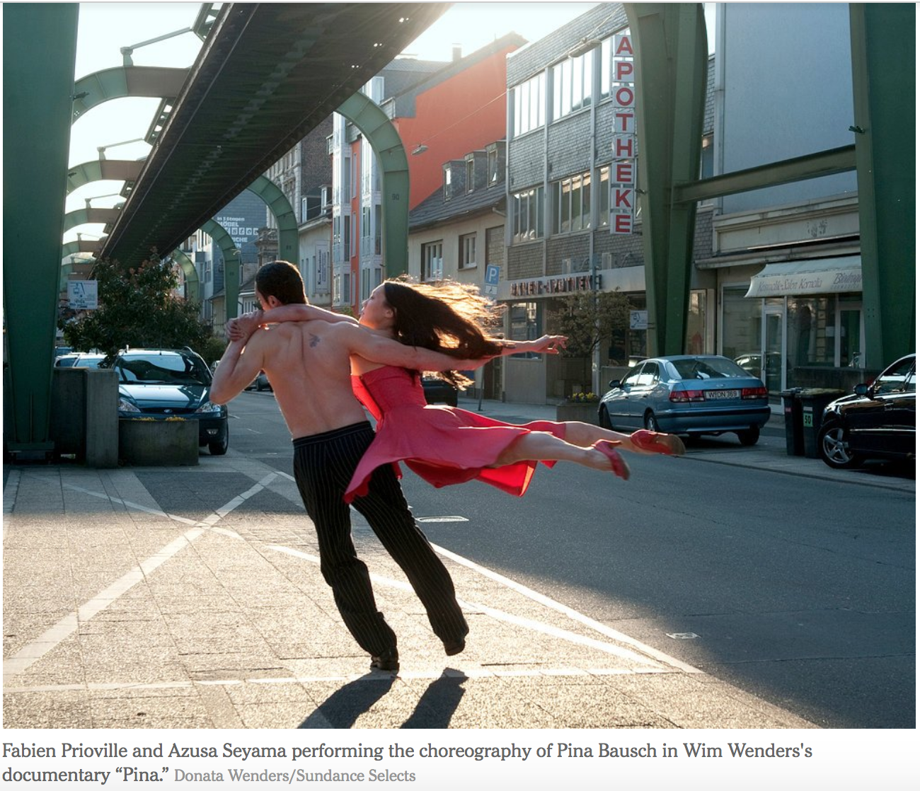

Mr. Herzog’s “Cave of Forgotten Dreams” and Mr. Wenders’s “Pina” are explorations of the artistic impulse, primordial and postmodern. “Pina” is a tribute to Pina Bausch, the German dancer and choreographer who died in 2009. Her work has appeared on film before; Pedro Almodóvar’s “Talk to Her” uses the dance “Café Müller” as an emotional touchstone. That piece, an obstacle course of wooden chairs and wild emotions set to music by Henry Purcell, figures prominently in “Pina,” encapsulating both Bausch’s aesthetic and Mr. Wenders’s desire to replicate on screen the depths and distances of the staging. A Photo Slide Show of Bausch’s Work

The dances in “Pina” take place on traditional stages and also on city sidewalks and tram cars (in Wuppertal, the northwestern German city where Bausch’s company is based), in forests and fields and, thanks to an especially ingenious coup de cinema, in what looks like a portable box. Alternating between highly stylized, precise gestures — of hands, fingers and faces as well as torsos and limbs — and more flowing and expressive movements, the dancers enact dramas of desire, sexual violence and the passage of time.

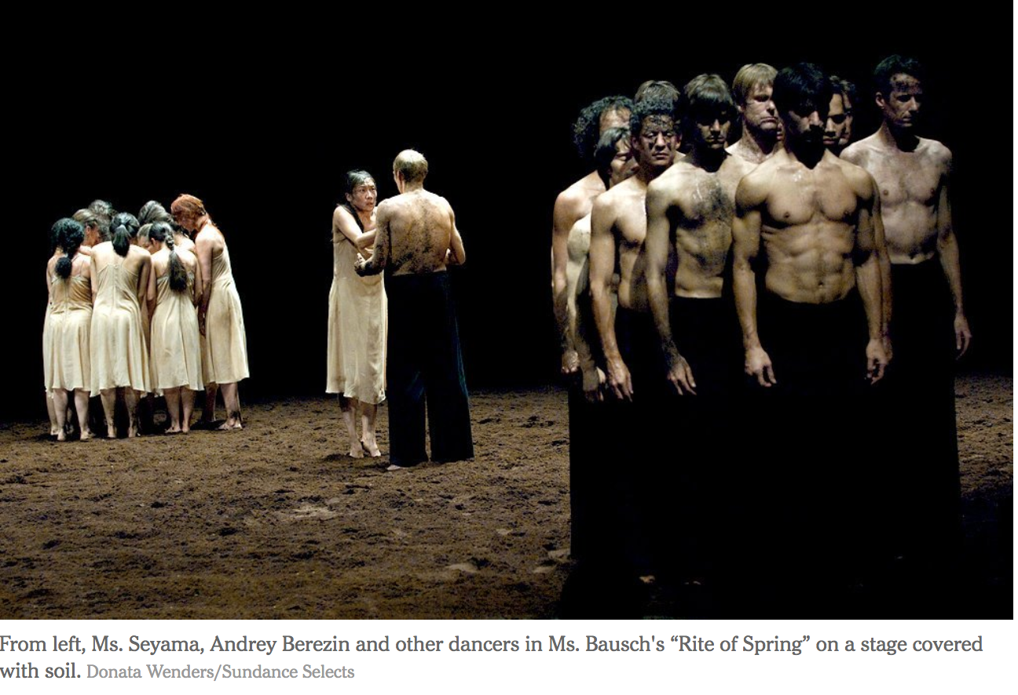

The cumulative effect is exhilarating and also a bit frustrating, since so many dances are included and woven together the audience does not have the chance to experience any single work in its entirety. But the power and intelligence of Bausch’s approach, which at times seems more cerebral than sensual, is communicated. And there are moments when her discipline and Mr. Wenders’s visual instincts harmonize perfectly, so that instead of enduring yet another well-meaning specimen of “dance on film” you are experiencing dance and film, fully and simultaneously.

In addition to the performances, “Pina” includes interviews with dancers, their words dubbed over their silent, contemplative faces. Instead of talking heads, they are thinking bodies, reflecting on the influence of their mentor. Their devotion to Bausch is evident, though the glowing tributes they offer also suggest that, like many charismatic artists, she cultivated something of a cult of personality. Diverse in age, body type and background, the dancers — speaking French, Russian, Portuguese, Japanese and other languages — convey their awe and gratitude in notably similar terms. “Pina used to say, ‘Be more crazy.’ ” “Pina used to say, ‘Surprise me.’ ” This is touching, but it leaves any analysis of her creative process and the ideas that drove it shrouded in a mist of generality.

But criticism is not really what Mr. Wenders intends. Choreography is a notoriously perishable art. Dances often struggle to outlive their creators. And “Pina” is, above all, an act of preservation, a memorial that is also a defiance of mortality — completely alive in every dimension.

PINA
Opens on Friday in New York.
Written and directed by Wim Wenders; directors of photography, Hélène Louvart and Jörg Widmer; edited by Toni Froschhammer; music by Thom Hanreich; produced by Mr. Wenders, Gian-Piero Ringel, Wolfgang Bergmann, Gabriele Heuser and Dieter Schneider; released by Sundance Selects. In German, English, Russian, Italian, French, Slovenian, Korean, Spanish and Portuguese, with English subtitles. Running time: 1 hour 43 minutes. This film is not rated.

http://www.nytimes.com/2011/12/23/movies/pina-a-documentary-by-wim-wenders-review.html

Pina, review

Pina Bausch’s brilliance is brought to life in 3D. Rating: * * * *
By Tim Robey
6:10PM BST 21 Apr 2011

3D, U cert, 106 min. Dir: Wim Wenders.
A gaggle of women, streaked with dirt and clinging to each other like panicked apes, huddle on stage. One by one, they come forward, proffering a small red dress in nervous entreaty, before fleeing back to their ranks. A lone man sizes them up sternly, his point of view giving us their detailed, fearful expressions in close-up, with the quivering scrum at the back of the shot. This is Pina Bausch’s interpretation of Stravinsky’s The Rite of Spring, reinterpreted for a 3D camera by Wim Wenders.
Pina, Wenders’s mesmerising dance-documentary fusion, proves that a third dimension can be more much more than icing on the cake. It reaches inside the late Bausch’s work and explores spatial relationships on the stage, using 3D to unlock her choreography for us. Shots are composed, through diaphanous scrims or with endlessly receding perspective, so that they only make true sense in 3D: opting for the alternative 2D isn’t just missing out, it’s missing the whole point.
Four of Bausch’s major works – The Rite of Spring, Café Müller, Vollmond and Kontakthof – are enacted at length, with shorter inserts, pas de deux and solo pieces also performed by members of her Tanztheater Wuppertal. Bausch’s death in 2009 makes the film inevitably a form of tribute, but one in which she retains a ghostly involvement – she and Wenders had been discussing the possibilities of a film for 20 years. There’s one snag: the performers offer short anecdotes and personal recollections of Pina, but these, often awkwardly interrupting the set pieces, are easily the least successful element of the film – we hear about her “strength and fragility” so many times the words cease to mean much. Everything we need to know about Bausch’s art, and indeed her character, is expressed better, more poetically, in motion.

http://www.telegraph.co.uk/culture/film/filmreviews/8467220/Pina-review.html

